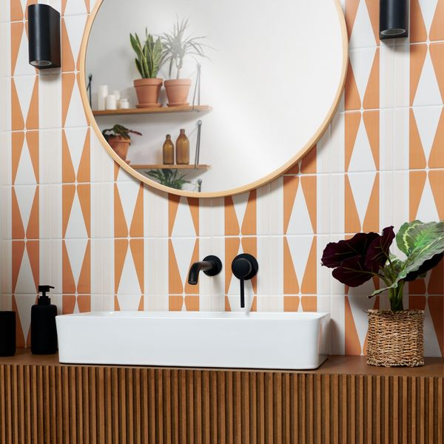**Marmalade Rene Pick n’ Mix Gloss Tiles:**

## **Product Description**

Looking for something a bit different to liven up your home? Our Marmalade Rene Pick n’ Mix Gloss Tiles feature a soft geometric design in sun-drenched shades of orange and cream. These tiles are designed to be moved around in different styles so that you can create a unique look for your home! Made from durable ceramic, these square-shaped tiles have a shimmering gloss finish that catches the light for a space-enhancing look.

**What’s special about these tiles?**

> Sunny shades of orange

> Durable ceramic

> Shimmering gloss finish

> Soft geometric pattern

> Can be turned to create different designs

## **Product Info**

* Product ID: 45096
* Tiles Per SQM: 44.444444444444
* Sale by: Per SQM
* Size: 150x150x8mm
* Weight: 0.28 KG
* Material Type: Ceramic
* Finish: Gloss
* Colour: Brown
* Suitability: Walls
* Rectified Edge: No
* Underfloor Heating: Yes
* Thickness (mm): 8